AGENT QUICK START GUIDE

Copyright

Under the copyright laws, neither the documentation, marketing materials, training materials, presentations nor the software PolicyPort may be copied, photocopied, reproduced, translated, or reduced to any electronic medium or machine-readable form, in whole or in part, without the prior written consent of TEAM FOCUS INSURANCE GROUP, LLC, except in the manner described in the applicable licensing agreement governing the use of TEAM FOCUS INSURANCE GROUP, LLC software or services.

#1 - LOG IN
Accessing the Online System

Go to: https://wwi.policyport.com/agent/portal

Login using the Username and Temporary Password that you will be provided. Make sure to change the Password to one you will easily remember the first time you log in. To change your password simply click on the menu item on the top bar and follow the instructions. Make sure you make a record of your new password.

My User Name _______________________________________
My Password _______________________________________
If you run into any problems, please call our office during business hours at 800-432-3072 Ext. 4325.

#2 - CREATE A QUICK QUOTE
Select 'Start New'.
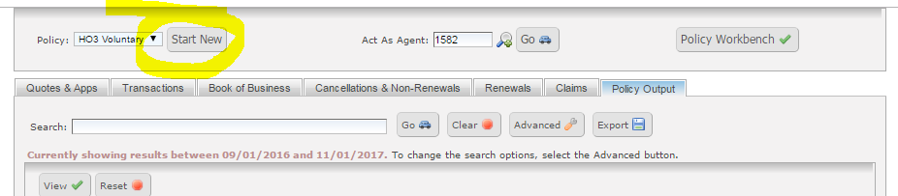
Complete the required information which is listed on the left-hand column marked with a red circle containing a "400" validation code.

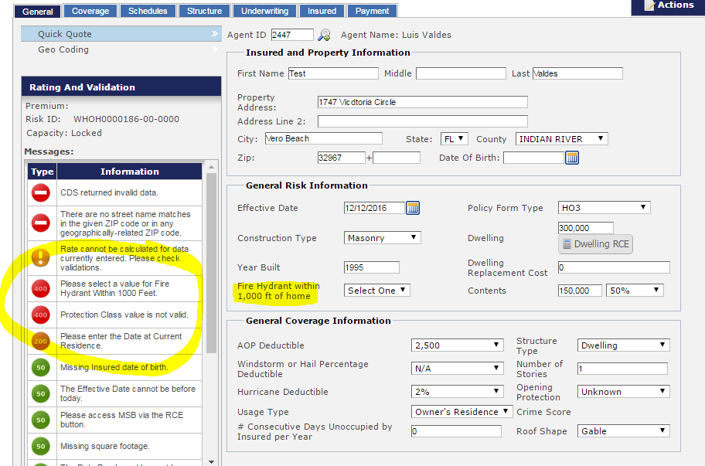
Note that to get an accurate, final quote you will need to complete all the requested information in the system.

Calculating the Replacement Cost and Insurance Limit
To complete the Replacement Cost Estimator (RCE), click on the button to open the RCE.
The screen grays out as a separate pop-up window opens for the RCE. Make any corrections, changes or additions to the data that has been automatically downloaded by the system in order to get an accurate description of the property. Click CALCULATE and FINISH and SAVE the data.

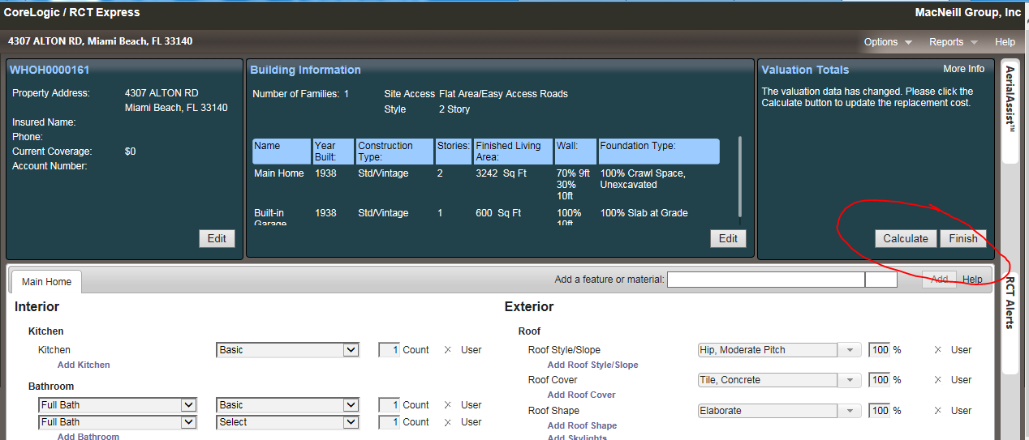

Exit the screen to go back to Policy Port. Click on EVALUATION COMPLETE and the calculated RCE will be displayed in the “Dwelling Replacement Cost” field.

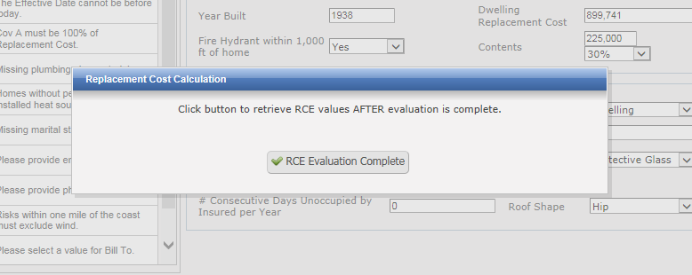

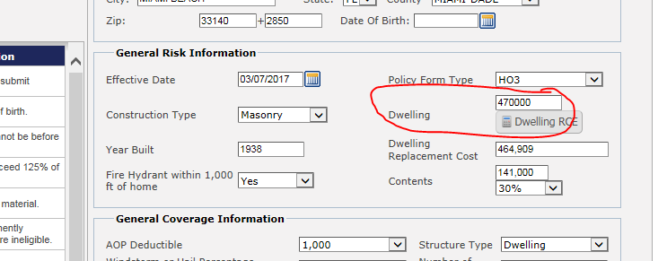

At this point, you can enter your selected coverage A amount in the DWELLING limit field. This amount should be no more than 25% above the RCV or 10% below.

NOTE: The Corelogic RCT Express Replacement Cost Estimator will obtain much of the required information from public sources, such as the County Appraisers’ databases. However, that information is sometimes incorrect or incomplete. Review the details of construction carefully to make sure you are using the most current and accurate information.

#3 - UNDERSTANDING VALIDATION MESSAGES

400-Level Validation Message – The agent is unable to obtain a premium. This validation message appears when a rating conflict exists or Underwriting Guidelines are not met and no exceptions are granted.

200-Level Validation Message – Allows the agent to obtain a premium but not submit or print the application.
150-Level Validation Message – Allows the agent to submit the application but it will not be auto-approved for binding. The agent is able to print the application.
75-Level Validation Message – Informational Message, but noted for exception in Underwriting.
50-Level Validation Message – Information Message only

All 400 and 200 Validations must be cleared before the agent is able to submit the risk for review. 150 validations allow the agent to submit and print the application for submission but will require underwriting review and approval prior to binding. If there are no 150 or higher validations the system will produce a Bound Application and ACORD binder after the agent clicks on Submit.

#4 - COMPLETE THE APPLICATION
Finding a quote is easy using the search feature in the Quote & Apps tab. Make sure to expand your search criteria by clicking on the ADVANCED tab and changing the time frame to “Search All” and then clicking on Configure.

Before submitting the application, complete all required fields and clear as many validation notices as possible. If no validations with a value of 150 or above appear, you will be able to bind the risk when you submit it. Otherwise the risk will be submitted for underwriting review before binding.
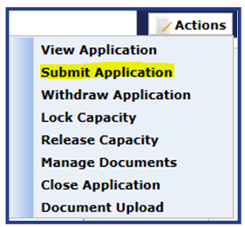
Click on the button on the top right-hand side and click on Manage Documents and Submit.

If you go back and search for the Quote number again, you will see that the Status column has changed from Application to Bound-Unapproved or Submitted-Unapproved.

#5- SUBMIT APPLICATION AND OTHER DOCUMENTS
Once you have successfully Submitted the risk, click on ACTIONS again and click on Manage Documents. A pop-up box will appear. Click on VIEW to have a PDF version of the application open. Once open, click on the Print Options or (Ctrl+P on your keyboard) to print out the application. Sign and have the insured sign the application, scan it and email to bind@macneillgroup.com along with the Diligent Effort form, prior cancellation or non-renewal, inspections, alarm certificates and any other supporting documentation.
If the application is BOUND, an ACORD binder will print as well. Unless there is a need for additional underwriting review, the policy will be bound as requested and issued once the signed application and documents are received in our office.
If the system is showing validations rated 150 or higher, the risk will not be BOUND until underwriting reviews and approves it. Note that the effective date may change.
NOTE: All required documents are due within 5 (five) business days from the date of submission.
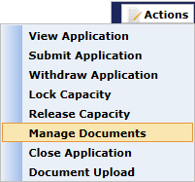
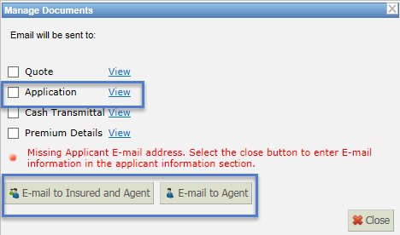

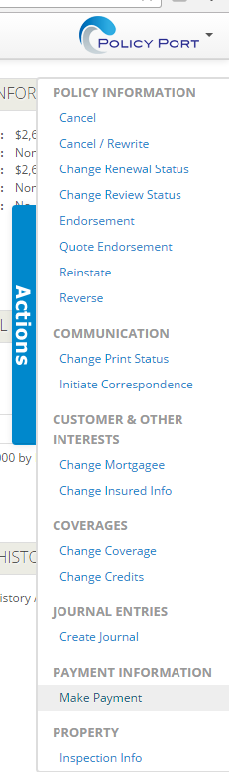
#6 - POST A PAYMENT TO THE ACCOUNT
If the application is in BOUND status, you may pay the premium once it is submitted by clicking on the PAYMENT tab and then on ELECTRONIC PAYMENT on the bottom right of the screen.
Once the risk has been submitted and approved, the policy will issue overnight with or without payment. You will have 21 days to pay the premium or the policy will cancel flat.
After the policy is issued, you may search for the account and double click on the Risk ID number. Click on the Actions slide-out tab on the right margin of the screen and then on Make a Payment and follow the instructions to pay via Master Card, Visa, Discover or e-check.
Note that there are no fees charged to the client for this service.
You may also mail your payment to our office or arrange for Premium Financing through Focus Premium Finance or another licensed premium finance company of your choice.

